VistA System Monitor (VSM) 1.0

Installation, Back-out, and Rollback Guide



August 2016

Department of Veterans Affairs (VA)

Office of Information and Technology (OI&T)

Enterprise Systems Engineering (ESE)

Capacity and Performance Engineering (CPE)

Revision History

| Date | Revision | Description | Author |
| --- | --- | --- | --- |
| 08/11/2016 | 1.0 | Initial Document. | J L: St Petersburg  Technical Writer: T. B. |

Table of Contents

Revision History ii

List of Figures iv

List of Tables iv

Orientation v

1 Introduction 1

1.1 Purpose 1

2 Pre-installation and System Requirements 2

2.1 Platform Installation and Preparation 2

2.2 Download and Extract Distribution Files 2

2.2.1 Software 2

2.2.2 Documentation 3

2.3 Installation Scripts 3

2.4 Cron Scripts 3

2.5 Access Requirements and Skills Needed for the Installation 3

3 Installation Procedure 4

3.1 Patch Installation Instructions 4

3.2 Caché Task Manager 4

3.3 Database Creation 4

4 Implementation Procedure 5

4.1 System Configuration—Post Installation 5

4.2 Database Tuning 5

4.3 Verify Installation 6

5 Back-out Plan 8

5.1 Back-out Strategy 8

5.2 Back-out Considerations 8

5.2.1 Load Testing 8

5.2.2 User Acceptance Testing 8

5.3 Back-out Criteria 8

5.4 Back-out Risks 8

5.5 Authority for Back-out 8

5.6 Back-out Procedure 8

6 Rollback Plan 9

6.1 Rollback Considerations 9

6.2 Rollback Criteria 9

6.3 Rollback Risks 9

6.4 Authority for Rollback 9

6.5 Rollback Procedure 9

List of Figures

Figure 1. VSM Management—Main 6

Figure 2. VSM Management—Menu: View Action 6

Figure 3. VSM Management—View Configuration 7

List of Tables

Table 1. Documentation symbol descriptions vi

Table 2. VSM Documentation 3

Orientation

How to Use this Manual

The Installation, Back-out, Rollback Guide defines the ordered, technical steps required to install the product, and if necessary, to back-out the installation, and to roll back to the previously installed version of the product.

Throughout this manual, advice and instructions are offered regarding the use of VistA System Monitor (VSM) 1.0 software and the functionality it provides for Veterans Health Information Systems and Technology Architecture (VistA) software products.

Intended Audience

The intended audience of this manual is the following stakeholders:

* Enterprise System Engineering (ESE)—System engineers and Capacity Management personnel responsible for enterprise capacity planning and system architecture.
* Information Resource Management (IRM)—System administrators and Capacity Management personnel at Department of Veterans Affairs (VA) sites who are responsible for computer management and system security on the VistA M Servers.
* Product Development (PD)—VistA legacy development teams.
* Product Support (PS).

Disclaimers

Software Disclaimer

This software was developed at the Department of Veterans Affairs (VA) by employees of the Federal Government in the course of their official duties. Pursuant to title 17 Section 105 of the United States Code this software is *not* subject to copyright protection and is in the public domain. VA assumes no responsibility whatsoever for its use by other parties, and makes no guarantees, expressed or implied, about its quality, reliability, or any other characteristic. We would appreciate acknowledgement if the software is used. This software can be redistributed and/or modified freely provided that any derivative works bear some notice that they are derived from it, and any modified versions bear some notice that they have been modified.

Documentation Disclaimer

This manual provides an overall explanation of using the VistA System Monitor (VSM) 1.0 software; however, no attempt is made to explain how the overall VistA programming system is integrated and maintained. Such methods and procedures are documented elsewhere. We suggest you look at the various VA Internet and Intranet SharePoint sites and websites for a general orientation to VistA. For example, visit the Office of Information and Technology (OI&T) Product Development (PD) Intranet Website.

 DISCLAIMER: The appearance of any external hyperlink references in this manual does *not* constitute endorsement by the Department of Veterans Affairs (VA) of this Website or the information, products, or services contained therein. The VA does *not* exercise any editorial control over the information you find at these locations. Such links are provided and are consistent with the stated purpose of this VA Intranet Service.

Documentation Conventions

This manual uses several methods to highlight different aspects of the material:

* Various symbols are used throughout the documentation to alert the reader to special information. Table 1 gives a description of each of these symbols:

Table 1: Documentation symbol descriptions

| Symbol | Description |
| --- | --- |
| Note | **NOTE / REF:** Used to inform the reader of general information including references to additional reading material. |
| Caution | **CAUTION / RECOMMENDATION / DISCLAIMER:** Used to caution the reader to take special notice of critical information. |
| Special Installation Note | **SPECIAL INSTALLATION NOTE:** Used to denote special installation instructions only (e.g., virgin installations or platform-specific steps). |

* Descriptive text is presented in a proportional font (as represented by this font).
* Conventions for displaying TEST data in this document are as follows:
* The first three digits (prefix) of any Social Security Numbers (SSN) begin with either “000” or “666”.
* Patient and user names are formatted as follows:
* *<APPLICATION NAME/ABBREVIATION/NAMESPACE>*PATIENT,*<N>*
* *<APPLICATION NAME/ABBREVIATION/NAMESPACE>*USER,*<N>*

Where “<*APPLICATION NAME/ABBREVIATION/NAMESPACE>*” is defined in the Approved Application Abbreviations document and “<*N*>” represents the first name as a number spelled out or as a number value and incremented with each new entry.

For example, in VSM (KMPV) test patient and user names would be documented as follows:

* KMPVPATIENT,ONE or KMPVUSER,ONE
* KMPVPATIENT,TWO or KMPVUSER,TWO
* KMPVPATIENT,THREE or KMPVUSER,THREE
* KMPVPATIENT,14 or KMPVUSER,14
* Etc.
* “Snapshots” of computer online displays (i.e., screen captures/dialogues) and computer source code is shown in a *non*-proportional font and may be enclosed within a box.
* User’s responses to online prompts are **bold** typeface and highlighted in yellow (e.g., **<Enter>**). The following example is a screen capture of computer dialogue, and indicates that the user should enter two question marks:

Select Primary Menu option: **??**

* Emphasis within a dialogue box is **bold** typeface and highlighted in blue (e.g., STANDARD LISTENER: RUNNING).
* Some software code reserved/key words are **bold** typeface with alternate color font.
* References to “**<Enter>**” within these snapshots indicate that the user should press the **Enter** key on the keyboard. Other special keys are represented within **< >** angle brackets. For example, pressing the **PF1** key can be represented as pressing **<PF1>**.
* Author’s comments are displayed in italics or as “callout” boxes.

 **NOTE:** Callout boxes refer to labels or descriptions usually enclosed within a box, which point to specific areas of a displayed image.

* This manual refers to the M programming language. Under the 1995 American National Standards Institute (ANSI) standard, M is the primary name of the MUMPS programming language, and MUMPS is considered an alternate name. This manual uses the name M.
* All uppercase is reserved for the representation of M code, variable names, or the formal name of options, field/file names, and security keys (e.g., the XUPROGMODE security key).

 **NOTE:** Other software code (e.g., Delphi/Pascal and Java) variable names and file/folder names can be written in lower or mixed case (e.g., CamelCase).

Documentation Navigation

This document uses Microsoft® Word’s built-in navigation for internal hyperlinks. To add **Back** and **Forward** navigation buttons to the toolbar, do the following:

1. Right-click anywhere on the customizable Toolbar in Word (*not* the Ribbon section).
2. Select **Customize Quick Access Toolbar** from the secondary menu.
3. Select the drop-down arrow in the “**Choose commands from:**” box.
4. Select **All Commands** from the displayed list.
5. Scroll through the command list in the left column until you see the **Back** command (green circle with arrow pointing left).
6. Select/Highlight the **Back** command and select **Add** to add it to your customized toolbar.
7. Scroll through the command list in the left column until you see the **Forward** command (green circle with arrow pointing right).
8. Select/Highlight the **Forward** command and select **Add** to add it to the customized toolbar.
9. Select **OK**.

You can now use these **Back** and **Forward** command buttons in the Toolbar to navigate back and forth in the Word document when selecting hyperlinks within the document.

 **NOTE:** This is a one-time setup and is automatically available in any other Word document once you install it on the Toolbar.

How to Obtain Technical Information Online

Exported VistA M Server-based software file, routine, and global documentation can be generated using Kernel, MailMan, and VA FileMan utilities.

 **NOTE:** Methods of obtaining specific technical information online is indicated where applicable under the appropriate section.  
  
**REF:** For further information, see the *VistA System Monitor (VSM) Technical Manual*.

Help at Prompts

VistA M Server-based software provides online help and commonly used system default prompts. Users are encouraged to enter question marks at any response prompt. At the end of the help display, you are immediately returned to the point from which you started. This is an easy way to learn about any aspect of VistA M Server-based software.

Obtaining Data Dictionary Listings

Technical information about VistA M Server-based files and the fields in files is stored in data dictionaries (DD). You can use the List File Attributes option on the Data Dictionary Utilities menu in VA FileMan to print formatted data dictionaries.

 **REF:** For details about obtaining data dictionaries and about the formats available, see the “List File Attributes” section in the “File Management” section in the *VA FileMan Advanced User Manual*.

Assumptions

This manual is written with the assumption that the reader is familiar with the following:

* VistA computing environment:
* Kernel—VistA M Server software
* VA FileMan data structures and terminology—VistA M Server software
* Microsoft® Windows environment
* M programming language

Reference Materials

Readers who wish to learn more about VSM should consult the following:

* *VistA System Monitor (VSM) Installation Guide* (this manual)
* *VistA System Monitor (VSM) User Manual*
* *VistA System Monitor (VSM) Technical Manual*
* Capacity and Performance Engineering (CPE) website (for more information on CPE services).

This site contains other information and provides links to additional documentation.

VistA documentation is made available online in Microsoft® Word format and in Adobe® Acrobat Portable Document Format (PDF). The PDF documents *must* be read using the Adobe® Acrobat Reader, which is freely distributed by Adobe® Systems Incorporated at: <http://www.adobe.com/>

VistA documentation can be downloaded from the VA Software Document Library (VDL): <http://www.va.gov/vdl/>

 **REF:** See the [VistA System Monitor (VSM) manuals on the VDL](http://www.va.gov/vdl/application.asp?appid=218).

VistA documentation and software can also be downloaded from the Product Support (PS) Anonymous Directories.

# Introduction

The VistA System Monitor (VSM) 1.0 software is intended to collect Caché and VistA metrics related to system capacity and business usage. The package will be made up of multiple collectors. The first collectors to be deployed are the following:

* VistA Timed Collection Monitor—Collects Caché metrics at regularly scheduled intervals such that they can be used in conjunction with metrics gathered via other deployed collection tools.
* VistA Storage Monitor—Collects storage metrics for each database once daily.

This data will be used for understanding VistA systems as they relate to the infrastructure on which they are deployed.

## Purpose

The purpose of this guide is to provide instructions for installing the Veterans Health Information Systems and Technology Architecture (VistA) Capacity and Performance Engineering (CPE) VistA System Monitor (VSM) 1.0 software.

# Pre-installation and System Requirements

## Platform Installation and Preparation

It is recommended that sites take the following approach to installing the VistA System Monitor (VSM) 1.0 software:

1. Obtain the VSM 1.0 documentation.
2. Install the software into a Test account.
3. Install the software into a Production system.

The following minimum software tools are required on your VistA Server in order to install and use the VSM software:

* VistA account running on InterSystems’ Caché for Linux, NT or OpenVMS.
* VistA accounts *must* contain the fully patched versions of the following packages:
* Kernel 8.0
* Kernel Toolkit 7.3
* MailMan 8.0
* VA FileMan 22.0

 **NOTE:** These software packages *must* be properly installed and fully patched prior to installing the VSM 1.0 software distribution. Patches *must* be installed in published sequence. You can obtain all released VistA patches (including patch description and installation instructions), from the Patch module on FORUM or through normal procedures.

The installation of VistA System Monitor (VSM) 1.0 software only affects the VSM options. Therefore, this installation can be performed at any time of the day with no disruption. Installation should take approximately 2 minutes.

## Download and Extract Distribution Files

### Software

The initial deployment of the VistA System Monitor (VSM) package is contained in the XU_8_568_V1.KID host file. Use the Kernel Installation & Distribution System (KIDS) to install the VistA System Monitor (VSM) 1.0 software.

This patch also contains bug fixes for the following existing capacity planning software:

* Statistical Analysis of Global Growth (SAGG) 2.0
* Resource Usage Monitor (RUM) 2.0
* Capacity Management (CM) Tools 3.0

### Documentation

Documentation for Vista System Monitor is available on the VA Software Document Library (VDL) at: <http://www.va.gov/vdl/application.asp?appid=218>.

VistA documentation and software can also be downloaded from the Product Support (PS) Anonymous Directories via File Transfer Protocol (FTP).

Table 2: VSM Documentation

| File Name | FTP Mode | Description |
| --- | --- | --- |
| kmpv_1_0_ig.pdf | Binary | VSM Installation, Back-out, and Rollback Guide |
| kmpv_1_0_um.pdf | Binary | VSM User Manual |
| kmpv_1_0_tm.pdf | Binary | VSM Technical Manual |

## Installation Scripts

There are no installation scripts for the Vista System Monitor (VSM) 1.0 software installation.

## Cron Scripts

There are no cron scripts for the Vista System Monitor (VSM) 1.0 software installation.

## Access Requirements and Skills Needed for the Installation

The installer needs to know how to do the following:

* Obtain VistA software from FORUM and File Transfer Protocol (FTP) download sites.
* Run a Kernel Installation & Distribution System (KIDS) installation.
* Use the VistA EVE menu.

# Installation Procedure

## Patch Installation Instructions

Patch installation instructions are documented in Kernel Patch XU*8.0*568 on FORUM. This is a standard VistA patch installation. Use the Kernel Installation & Distribution System (KIDS) to install the VistA System Monitor (VSM) 1.0 software. Monitors will be started automatically.

This installation creates the ^KMPV global to store the following VSM files:

* VSM CONFIGURATION (#8969): Contains configuration parameters for each monitor and most recent run times.
* VSM MONITOR DEFAULTS (#8969.02): Contains default configuration parameters for each monitor allowing restoration of monitor defaults.
* VSM CACHE TASK LOG (#8969.03): Contains run time for each monitor and node for forensic purposes. This file will be purged upon each monitor run to contain a maximum of 6 months of entries.

The ^KMPTMP(“KMPV”) global is used to store temporary VSM data. This global contains data for only a single day with normal operations. To ensure global size is kept to a minimum a purge function is run at the daily start of all monitors. Data is kept only up to the maximum number of days configured in the VSM CONFIGURATION file (#8969). This parameter has a maximum of seven (7) days.

 The ^KMPTMP("KMPR") global should *not* be journaled!

 **REF:** Details regarding imported files, options, protocols, etc. can be found in the *VSM Technical Manual*.

## Caché Task Manager

The VistA Timed Collection Monitor is dependent on the Caché Task Monitor to start the collection routine each morning on each node of the VistA environment.

 **REF:** To create this task, see the post installation steps in Section 0.

## Database Creation

The VSM 1.0 software installation does *not* create any databases. VSM uses the existing VA FileMan database.

# Implementation Procedure

## System Configuration—Post Installation

 SPECIAL INSTALLATION NOTE: Add Caché Task Manager Task on each Node.

Once this patch has been installed, the VSM Driver Task *must* be added to the Caché Task Manager (*not* VistA TaskMan). The user *must* have either of the following roles:

* %All Role
* %Manager Role

The installer, or someone with the proper permissions, *must*:

1. Log directly on to each Front-end node and on to the Back-end node.
2. Execute the following at a command prompt:

**D KMPVTSK^KMPVCBG**

CHY> **D KMPVTSK^KMPVCBG**

If the user gets an error based on $ZDEFNSP *not* being available then pass your default namespace as follows:

CHY> **D KMPVTSK^KMPVCBG(namespace)**

These steps will add the VSM Driver Task to each node. This step is essential for the proper operation of the VistA System Monitor.

 **NOTE:** For test systems, in lieu of running the collections via the Caché Task Manager, you could run the line tag RUN^KMPVRUN to start a single days collection on a given node.

## Database Tuning

There are no special database tuning requirements for the VSM 1.0 software installation.

## Verify Installation

To verify the VSM installation, perform the following procedure:

1. Use the VSM MANAGEMENT option located under the Capacity Planning option to verify the VSM installation:

Figure 1: VSM Management—Main

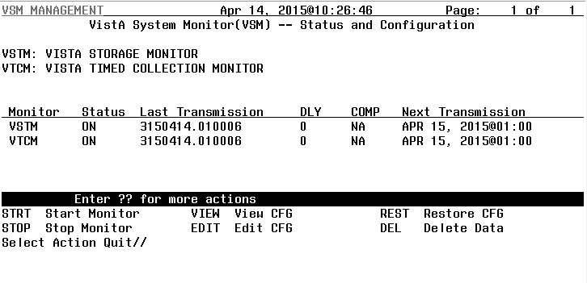

1. Once in the VSM MANAGEMENT screen, choose **VIEW** and then the monitor in question:

Figure 2: VSM Management—Menu: View Action

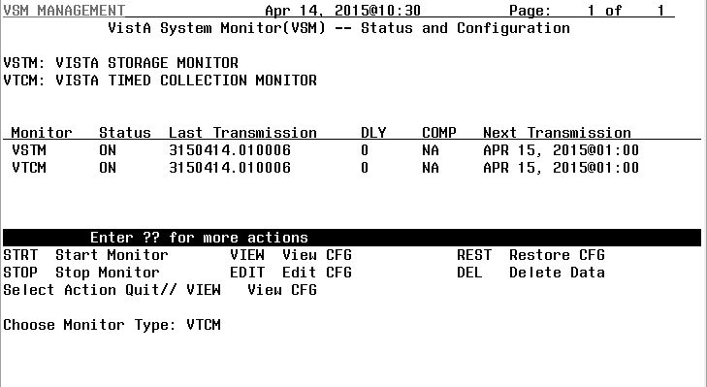

1. A screen like Figure 3 is displayed:

Figure 3: VSM Management—View Configuration

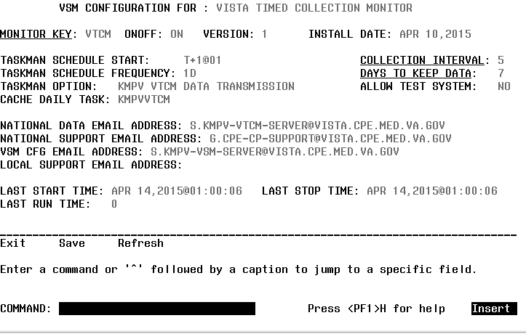

 **NOTE:** The Monitor is turned on by default.

# Back-out Plan

Back-out pertains to a return to the last known good operational state of the software and appropriate platform settings.

In the case that a back-out of this release is required a patch will need to be created and deployed to all sites that have installed the original patch. In the case of an initial release this new patch would need to remove any existing data, remove Veterans Health Information Systems and Technology Architecture (VistA) files associated with the package and remove routines associated with this package. Contents of a back-out patch for future releases would be dependent on the functionality released at that time.

 **NOTE:** For patch back-out procedures, see the patch description.

## Back-out Strategy

The need for a back-out would be determined by all affected organizations. This would primarily include representatives from Veterans Health Administration (VHA) and Enterprise System Engineering (ESE) Capacity and Performance Engineering (CPE). In the case of the initial release a back-out would include removal of data, files and routines. In the case of future patches and releases the back-out strategy would be dependent on the contents of the released functionality and could include restoration of file definitions, routines or data.

## Back-out Considerations

Back-out considerations would include impact on production VistA end users and impact on Wide Area Network.

### Load Testing

Not applicable for VSM.

### User Acceptance Testing

VSM User Acceptance Testing (UAT) is performed during VistA patch testing at test sites.

## Back-out Criteria

The VSM back-out criteria follow existing VistA back-out procedures

## Back-out Risks

The VSM back-out risks are the same risks established with existing VistA back-out procedures.

## Authority for Back-out

The authority for the need of back-out would reside with VHA and ESE CPE representatives.

## Back-out Procedure

The VSM back-out procedure would include the creation of a patch to remove data, files and routines for an initial installation. Back-out of future releases would include a patch, with the contents of the back-out patch to be determined by the content of the released functionality and related issues.

# Rollback Plan

Rollback pertains to data.

The VistA System Monitor (VSM) 1.0 software collects system data through the day and sends that data to the national database on a nightly basis. Data is deleted at the site upon acknowledgement from the national server that data has been received. If there is a problem with receiving the acknowledgement, then data is purged after seven (7) days. In the case that the purge does *not* work then the monitors can be stopped and all data deleted at the site using the “Delete Data” action. This is found on the main VistA menu:

Capacity Planning…

VSM MANAGEMENT

Delete Data

## Rollback Considerations

VSM data should be deleted only if it has been determined that the automatic data management features are not working.

## Rollback Criteria

VSM data should be deleted if there are more than seven (7) days of data in the ^KMPTMP(“KMPV”, global.

## Rollback Risks

The risk to rollback would be the loss of system metrics for that period of time. This risk is much less than any potential harm to a system and should be considered a low risk.

## Authority for Rollback

Rollback *can* be authorized by system administrators once a problem has been identified. The Capacity & Performance Engineering group should be informed immediately *via a MailMan message sent to:*

G.CPE-CP-SUPPORT@VISTA.CPE.MED.VA.GOV

## Rollback Procedure

Data can be deleted at the site using the “Delete Data” action. This option is found on the main VistA menu:

Capacity Planning…

VSM MANAGEMENT

Delete Data